This is how I am displaying all of the portfolio information. 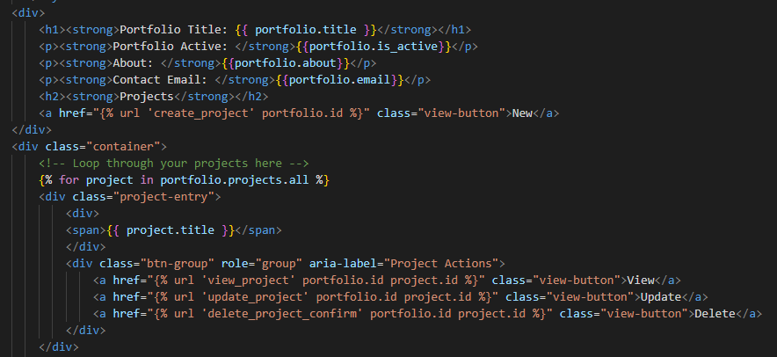

Above is just how I am styling the web page but this is the bulk of the code. At the top, it is getting the portfolio title, if the portfolio is active, about the portfolio, contact email for the student who owns the portfolio, and all the projects inside the portfolio. This is a one to one relationship because each student is only going to have one portfolio.

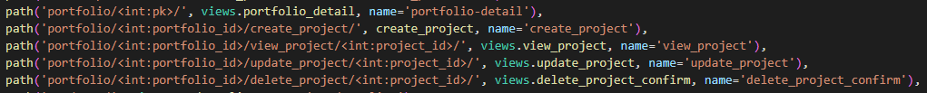

These are all the urls that control where the user is going on the web page when clicking on different buttons. All the buttons can be found on the portfolio information page.

This is the code for the project details. Once the user clicks on the view button for a project on the portfolio page it will take them here. 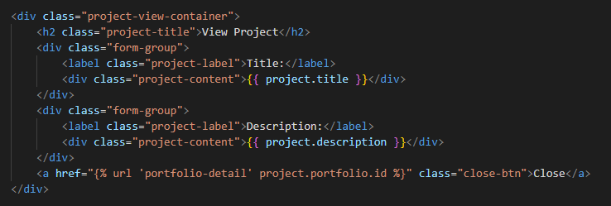

All this is doing is displaying the title of the project, and the description of that project. After the user can click on the close button and it will redirect them back to the students portfolio page. Here is the code in the view.py that is doing the behind scenes logic. 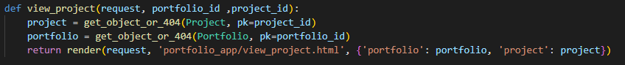

Finally, the student details. 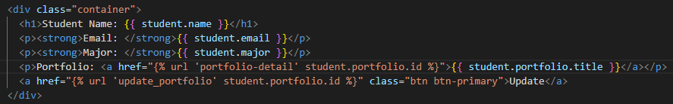

Like before the code isn’t super complex, all it is doing is displaying the students name, email, major, and their portfolio. The user can then click on the portfolio link and it will take them to the portfolio details page with all the students' projects or they can click the update button and that will allow the user to update any information they want on their portfolio.